Customer Information Report
Objective
To retrieve customer details and analyze customer distribution and purchasing activity.
SQL Operations Performed
- Retrieved all customer records.
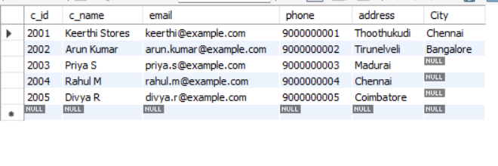
- Displayed customers alphabetically by name.
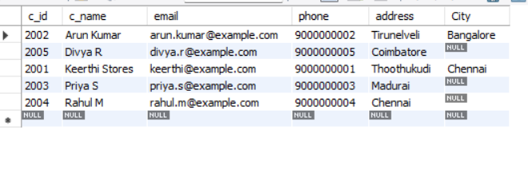
- Identified customers from specific cities.
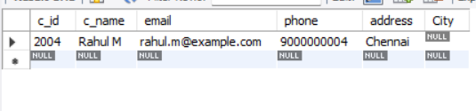
- Counted the total number of customers.
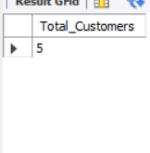
- Calculated the number of customers in each city.
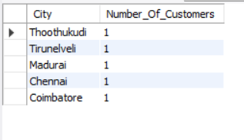
- Displayed customer details along with their orders.
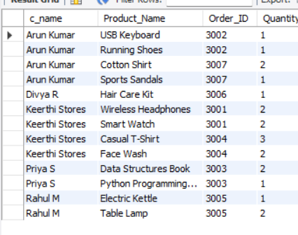
- Identified customers who purchased specific products.
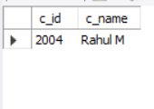
Result
The queries provide information about customer locations, registrations, orders, and purchasing activity. This information helps understand the customer base and organize customer records.
Conclusion
SQL queries support efficient customer information retrieval and provide useful insights for customer management and business planning.

